|  |
| --- |
| PROPOSAL -- SOFTY PVT.LTD |

|  |
| --- |
| CAPSTONE PROJECT – GROUP MEMBER |

|  |  |
| --- | --- |
| NO. | NAME |
| 1 | GUPTA LUCKY (GROUP LEADER) |
| 2 | PATEL DHRUMIL |
| 3 | GAJJAR MILAN |
| 4 | SHAH VISHESH |
| 5 | PATEL AKSHAT |

--------------------------------------------------------------------------------------------------------------------------------------

SOFTY PVT.LTD SINCE 2021

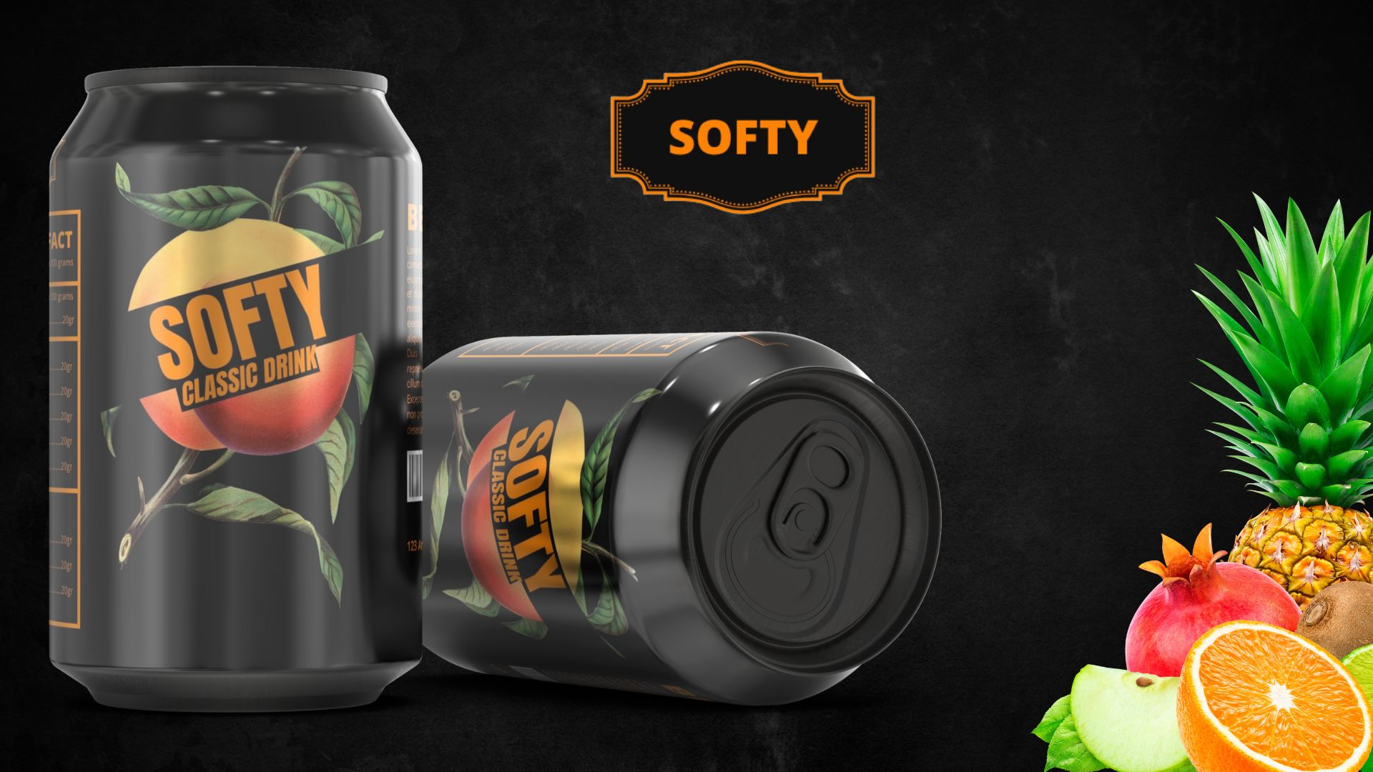

ABOUT:

>> WELCOME TO OUR SOFTY PVT.LTD! WE ARE A PASSIONATE TEAM OF BEVERAGE EXPERTS DEDICATED TO CRAFTING THE PERFECT SOFT DRINK TO SATISFY YOUR THIRST AND TANTALIZE YOUR TASTE BUDS.

>> OUR STORY BEGAN WITH A LOVE FOR CREATING DELICIOUS, REFRESHING DRINKS THAT COULD BE ENJOYED BY PEOPLE OF ALL AGES. WE STARTED SMALL, EXPERIMENTING

WITH DIFFERENT FLAVORS AND INGREDIENTS UNTIL WE DISCOVERED THE PERFECT COMBINATION OF SWEETNESS, FIZZ, AND FLAVOR.

PRODUCTS:

>> OUR COMPANY CAN MANUFACTURING GENERALLY FOUR PRODUCTS.

* NAME - ABOUT

1. ORANGE - TAQUILA DRINK: ORANGE-TEQUILA COCKTAIL IS A REFRESHING AND DELICIOUS DRINK THAT'S PERFECT FOR SUMMER DAYS OR ANY TIME YOU WANT A FUN AND EASY-TO-MAKE COCKTAIL.

2. LITCHI - LOVELY DRINK: LITCHI IS A DELICIOUS AND JUICY FRUIT THAT CAN BE USED TO MAKE A REFRESHING AND LOVELY DRINK.

3. LEMON - NAUGHTY DRINK: A NAUGHTY LEMON DRINK MIGHT BE A FUN AND PLAYFUL COCKTAIL THAT INCLUDES A BIT OF A KICK. ENJOY YOUR NAUGHTY LEMON DRINK.

4. JEERA - CLASSIC DRINK: JEERA IS A POPULAR INDIAN DRINK THAT IS BOTH REFRESHING AND FLAVORFUL. ENJOY YOUR JEERA-CLASSIC DRINK.

*RAW MATERIAL:

>> THE RAW MATERIALS NEEDED TO MAKE COLD DRINKS CAN VARY DEPENDING ON THE SPECIFIC TYPE OF DRINK YOU WANT TO MAKE. HOWEVER, HERE'S A GENERAL LIST OF INGREDIENTS COMMONLY USED TO MAKE COLD DRINKS:

: NAME--

1.CARBONATED WATER OR STILL WATER

2.FRUIT JUICES (ORANGE, APPLE, GRAPEFRUIT, CRANBERRY, PINEAPPLE, ETC.)

3.SYRUPS (SIMPLE SYRUP, FLAVORED SYRUPS LIKE STRAWBERRY, RASPBERRY, OR PEACH)

4.SWEETENERS (SUGAR, HONEY, AGAVE NECTAR, OR ARTIFICIAL SWEETENERS)

5.FRUITS (LEMON, LIME, ORANGE, STRAWBERRY, RASPBERRY, WATERMELON, ETC.)

6.HERBS AND SPICES (MINT, BASIL, GINGER, CINNAMON, NUTMEG, ETC.)

7.MILK OR CREAM (FOR MILKSHAKES OR SMOOTHIES)

8.ICE CUBES OR CRUSHED ICE.

* COST-PER PRODUCT: (2021-2022)

|  |  |  |
| --- | --- | --- |
| NO. | PARTICULARS | PRICE |
| 01. | CARBONATED WATER | RS. 5.00/- |
| 02. | CAN (IMPORT OTHER COMPANY) | RS. 8.50/- |
| 03. | FLAVOUR SYRUPS | RS. 6.00/- |
| 04. | SUGAR | RS. 5.00/- |
| 05. | PACKAGING COST(INCLUDE MACHINERY) | RS. 8.00/- |
| 06. | OTHER CHARGE (MARKETING, LABOUR) | RS. 12.00/- |
|  | TOTAL | RS. 44.50/- |
|  | + GST (12%) | RS. 5.50/- |
|  | TOTAL PRICE PER PRODUCT | RS. 50.00/- |

* SALE:

>> OUR COMPANY SALES TYPE IS B2B.

>> SALE PRICE🡪 60.00/-(WHOLE SELLER)🡪 65.00/-(RETAILER)🡪70.00/- (CUSTOMER)

>> PROFIT MARGIN = 10.00/- (PER PRODUCT)

*LAST YEAR SALE: (DATA ANALYSIS)

* COST-PER PRODUCT: (2022-2023)

|  |  |  |
| --- | --- | --- |
| NO. | PARTICULARS | PRICE |
| 01. | CARBONATED WATER | RS. 5.00/- |
| 02. | CAN (IMPORT OTHER COMPANY) | RS. 9.50/- |
| 03. | FLAVOUR SYRUPS | RS. 6.50/- |
| 04. | SUGAR | RS. 6.00/- |
| 05. | PACKAGING COST | RS. 8.00/- |
| 06. | OTHER CHARGE (MARKETING, LABOUR) | RS. 15.00/- |
|  | TOTAL | RS. 50.00/- |
|  | + GST (12%) | RS. 5.50/- |
|  | TOTAL PRICE PER PRODUCT | RS. 56.00/- |

* SALE:

>> SALE PRICE🡪 66.00/-(WHOLE SELLER)🡪 71.00/-(RETAILER)🡪76.00/- (CUSTOMER)

>> PROFIT MARGIN = 10.00/- (PER PRODUCT)

*CURRENT YEAR SALES:

* PRODUCTS PHOTO –

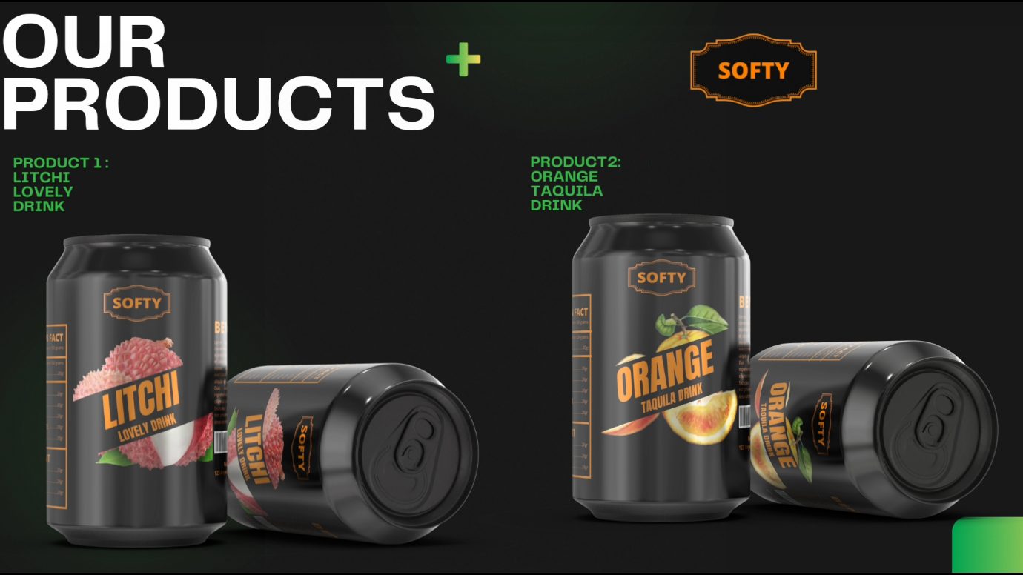

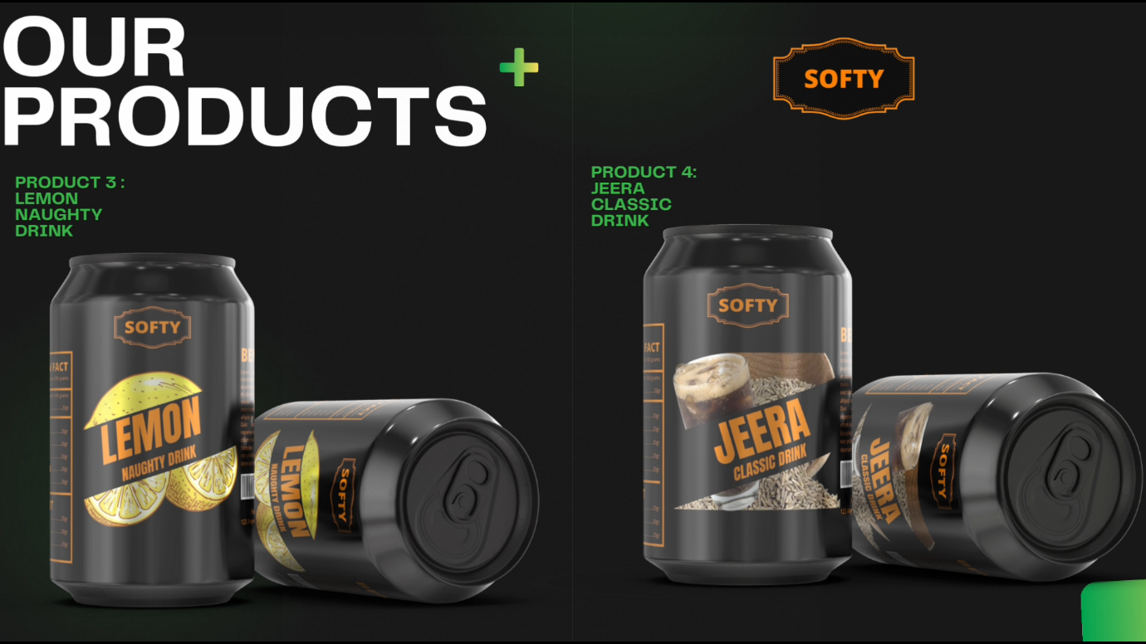

>>WEBSITE – SOFTY COMPANY.

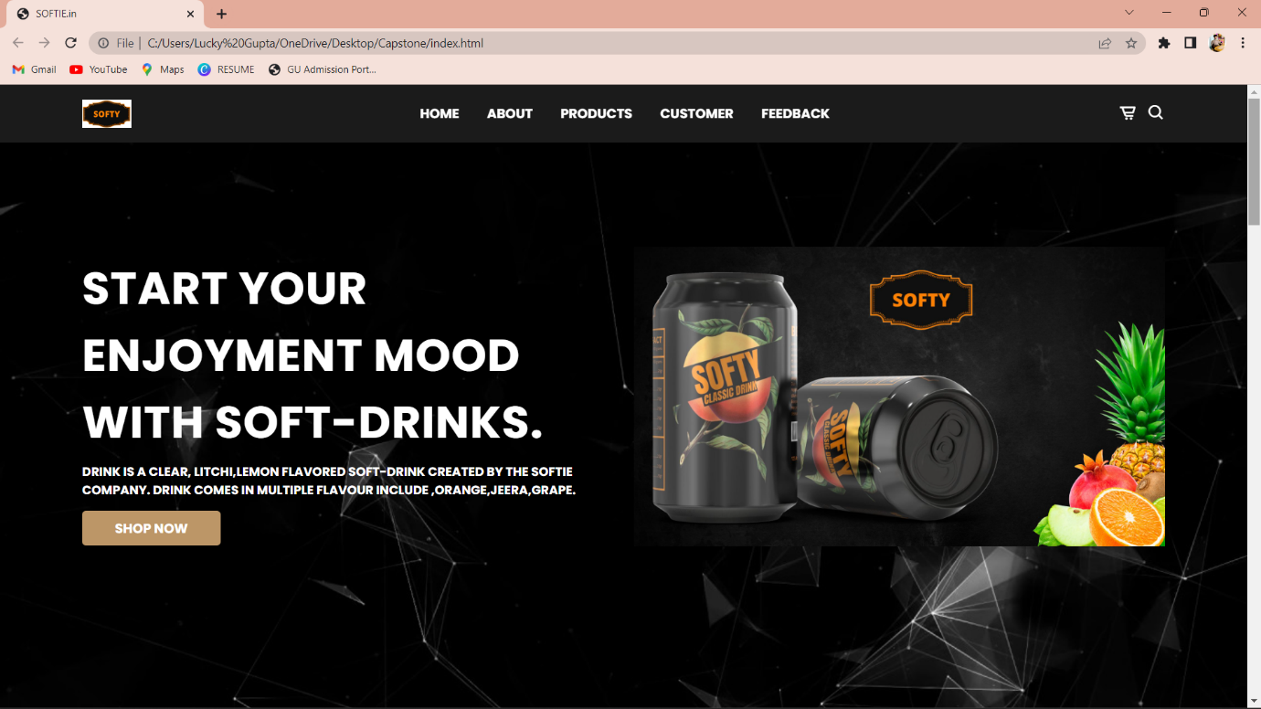

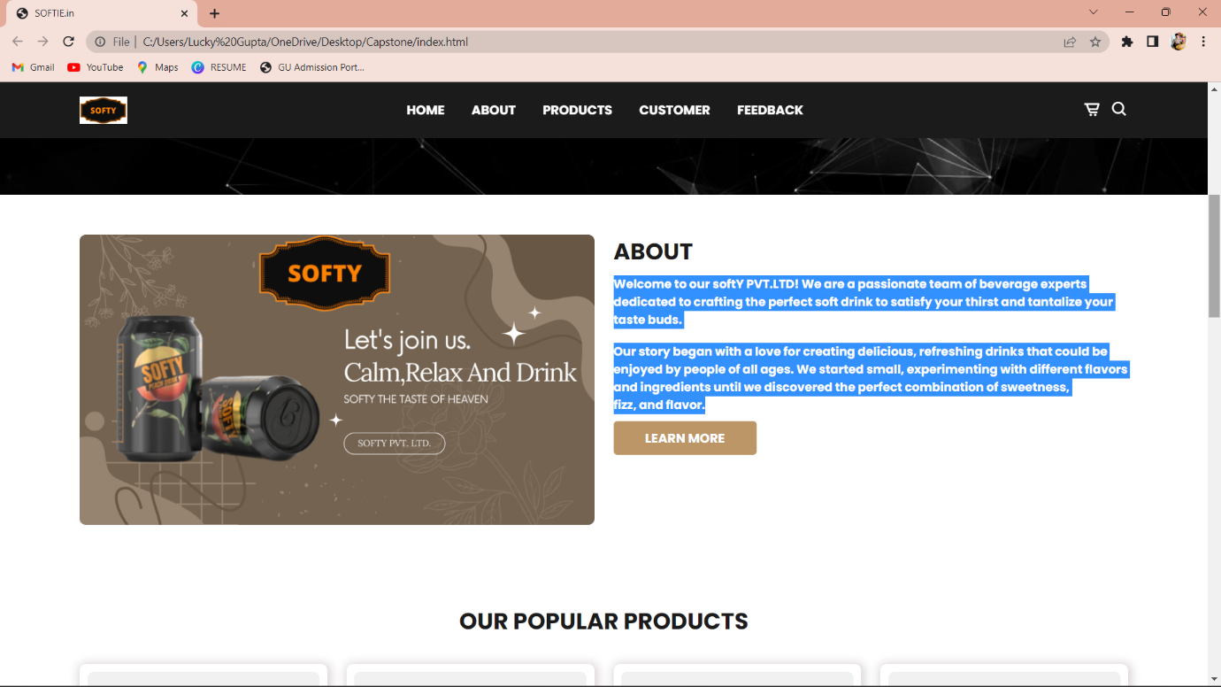

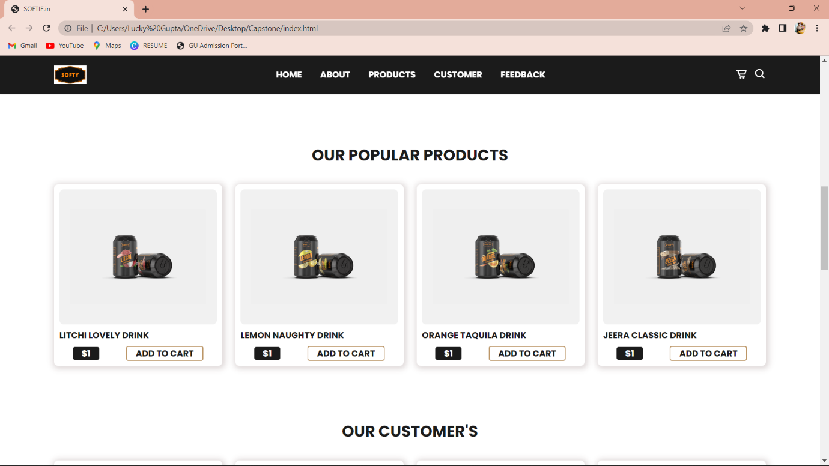

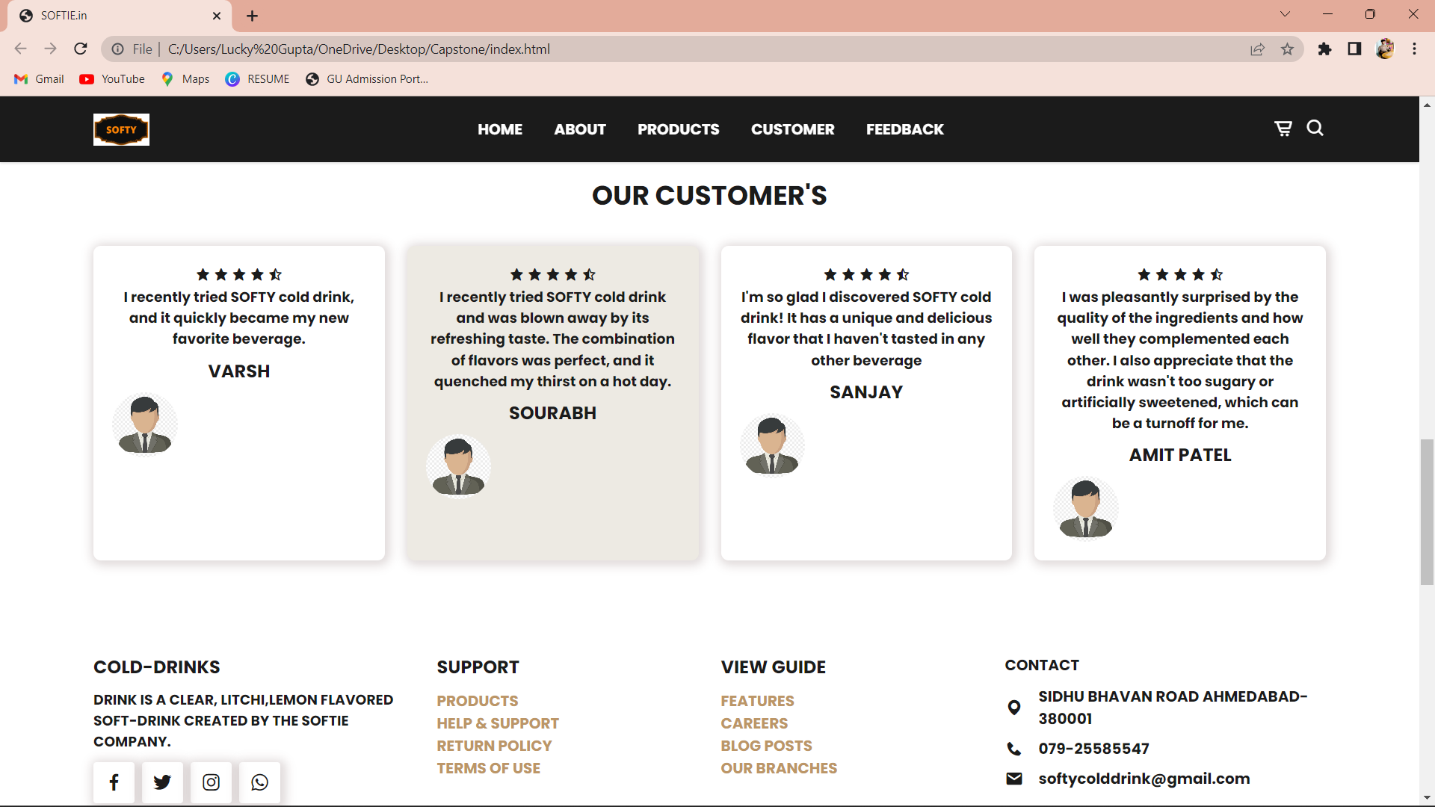

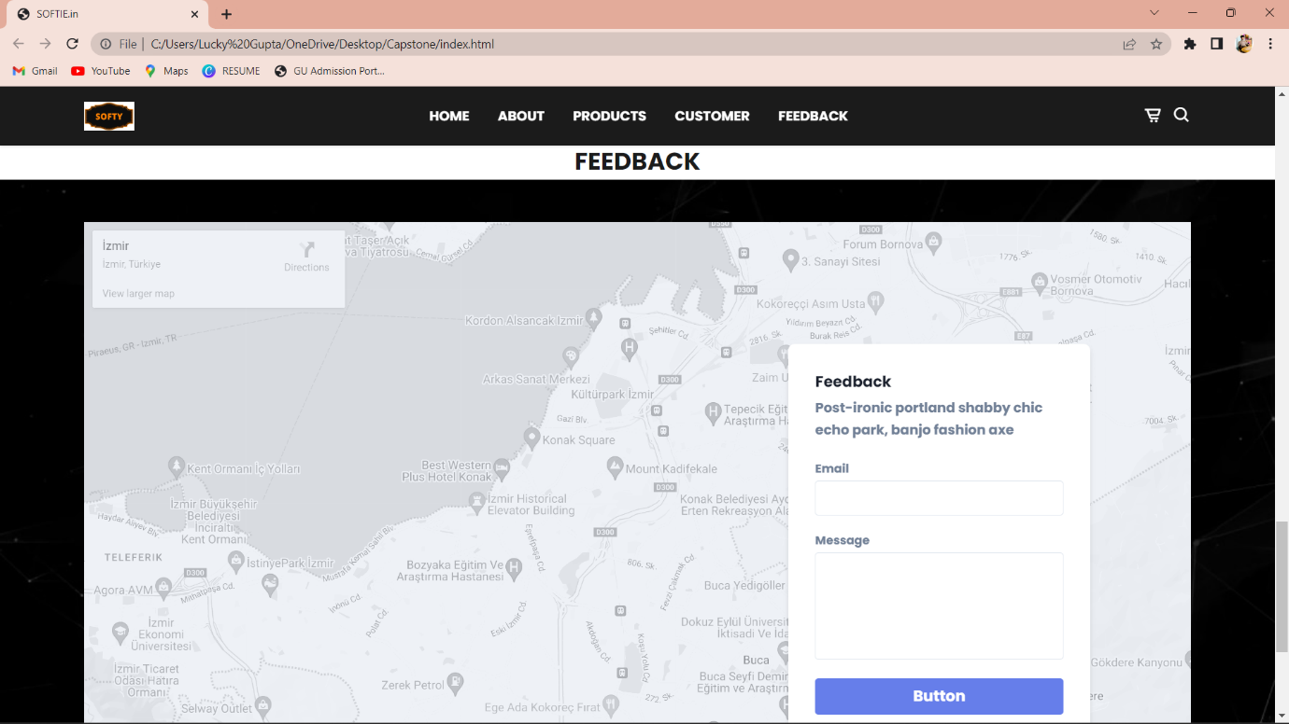

OUR TEAM >

* COMPANY OWNER 🡪 GUPTA LUCKY
* SALES MANAGER 🡪 VISHESH SHAH
* MARKET- ANALYSE 🡪 GAJJAR MILAN
* FINANCE 🡪 PATEL DHRUMIL
* SUPERVISIOR 🡪 PATEL AKSHAT

SOFTY PVT.LTD